**Final Project Journal Preparing For the final project**

**Dave Hinds**

**Southern New Hampshire University**

**June 28th, 2020**

**1.** **Screenshot of your modified Hello World App**

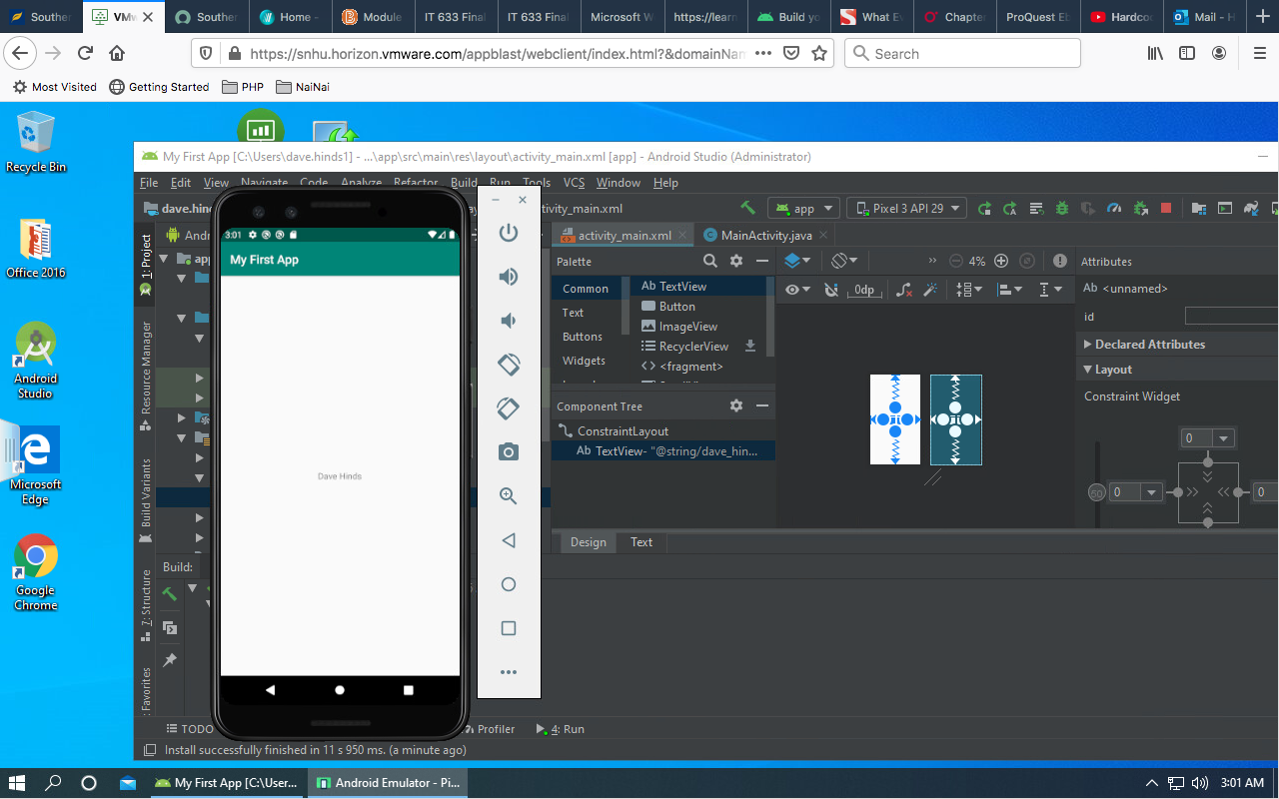

**2) Any challenges you faced during the installation and configuration and how you overcame those challenges**

The only challenge I encounter in developing my app was something with driver compatibility when I attempted to create my virtual device…the driver was eventually updated.

**3) The functionality set you selected for the final project, including your justification for choosing that particular functionality set**

The functionality that I selected for my final project is project four (Healing Hospital). I think with everything thats happening in the world and especially in our country, I have had so many people ask about developing similar portal for their clinics and practices. Their focus is trying to do more telenet visits and allowing their patients to enjoy an app that gives them the comfort of knowing that their healthcare team is accessible at any time. I like the way the mock-up is setup. This will certainly accomplish the needs of my future clients.